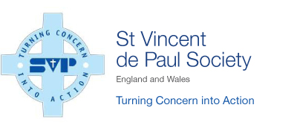
ITEMS WE ARE UNABLE TO COLLECT

Furniture
- Large wall units wider than 5ft.
- Sideboards over 5ft in length or height
- Fitted bedroom furniture
- Single armchairs (unless a recliner or similar)
- Fitted kitchen units
- Sinks, baths and fitted bathroom units
- Any furniture items that do not comply with the 1988 Fire safety regulations (missing fire labels)
- Items that do not contain safety glass (with the Kite mark)
- Large office desks
- Stained, ripped or torn mattresses with a fire label sewn in (BS7177)
- Large dining tables over 5ft
- Furniture with any missing parts

Electrical Items
- Box TV’s larger than 35inch
- Electric showers
- Power tools without instructions
- Sunbeds and tanning equipment
- Set top boxes e.g. Sky, Virgin etc.
- Broadband routers

Heating & Cooking
- Gas cookers
- Gas appliances (mains or bottled)
- Mobile oil filled heaters
- Storage heaters

Miscellaneous
- Child safety seats
- Piano’s or large organs
- Ironing boards with an “asbestos rest plate”
- Safety helmets including cycle, riding and crash helmets
- Safety harnesses of any sort
- Fire fighting equipment

White goods
- White goods and electrical items without a “CE” mark

Quality notice – please note there may be quality and/or safety reasons why we are unable to collect some items. Any items that we are able to collect must be of good quality so that we can sell in our local Community Shops or pass on direct to those in need through members’ of the Society. We are unable to accept broken, ripped, scratched, stained or torn items of any kind.

Thank you for helping us turn concern into action!

