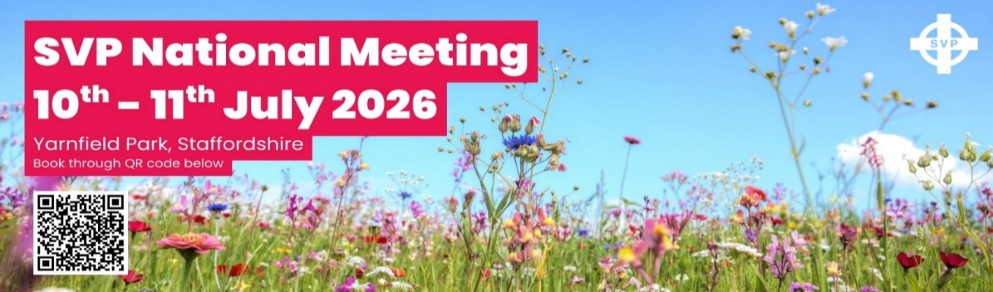
Programme
Friday 10 July 2026
08.30- 10.15 Registration, coffee and exhibition time
09.30 –10.00 Early bird session
Getting Conferences started – Joe Gason/Kate Birkenhead/Bethany Moreland, membership team
10.15 Welcome - Elaine Heyworth, National President
Spiritual reflection -Peter McGauley, Trustee
The way ahead – Elaine Heyworth
10.40 A member led Society – Miko & Dorothee Giedroyc, Kate Nightingale, and Sarah Barber
11.10 Special Work – Bereavement Café’s – Gina Pilley, member
11.40 Q&A’s
11.55 Break
12.15 Seminars: Choose 1 * repeated on Saturday
• A – Supporting our Prisons group – Gustavo Vas Falcao
• * B – Developing Young Vincentians in your CC – Sarah Barber/Kezia Harrow
• C – Special Conference Initiatives – Warm Spaces - Lance Philpott
•* D – Setting up Conference Fundraising events – Bethany Moreland/Kate Birkenhead
13.00 LUNCH
14.00 Georgina, Duchess of Norfolk, SVP Patron
14.15 Work of the Conferences – St Peter’s & St Michaels Furniture Project –Sheila and Keith Padwick, members
14.45 Q&A’s
15.00 COFFEE and exhibition time/shop
15.30 Advocacy: How our members can be a voice for the voiceless – Sir John Battle, SVP Patron
16.00 Q&A’s
16.15 Learnings from the day
16.30 Mass with Fr Eugene Curran
17.30 Close
18.30 -19.30 Dinner (“The Old Oak” Ken Loach Film in the main room (optional) and/or drinks in the bar)

Saturday 11 July 2026
7.00-8.30 Breakfast
08.30-10.15 Registration, seminars, coffee and exhibition
08.45-09.15 Seminars (select from A or B)
A: Setting up Conference Fundraising events – Bethany Moreland/Kate Birkenhead
B: Conference finance – Qubra Bibi/Alsu Bairamova, membership finance
09.20-10.00 Seminars (select from A, B, C,D)
A: Developing Young Vincentians in your CC – Julia Fitzgerald, Katy Ramsey
B: Legacies receiving one and leaving one – Hannah Brimley/Steff de Simone
C: Fundraising and supporting requests for help – Bethany Moreland/Andrew Daines, membership team
D:Faith in Action and Training and developing members – Sarah Barber
10.15 Welcome, reflections from day 1 – Elaine Heyworth, National President
10.25 Spiritual reflection, SVP Trustee
10.30 SVP and Caritas working together – Richard Harries, Director Caritas Westminster
11.00 Q&A’s
11.15 The role of Charity in the Church – Fr. Tom Cunnah
11.45 Succession Planning for the Future – Joanna & Winston Waller
12.15 Q&A’s
12.30 Exhibition and Shop time
13.00 Lunch
14.00 Our members in pilgrimage – Camino and beyond – Elaine Heyworth and members
14.30 Q&A’s
14.45 Summary of the event – Elaine Heyworth
15.00 - 15.30 Commissioning Service and closing prayers & Hymns and depart. Fr. Eugene

